SOP for Formlabs Custom trays and Wax Rims

By:

Katherine Lala

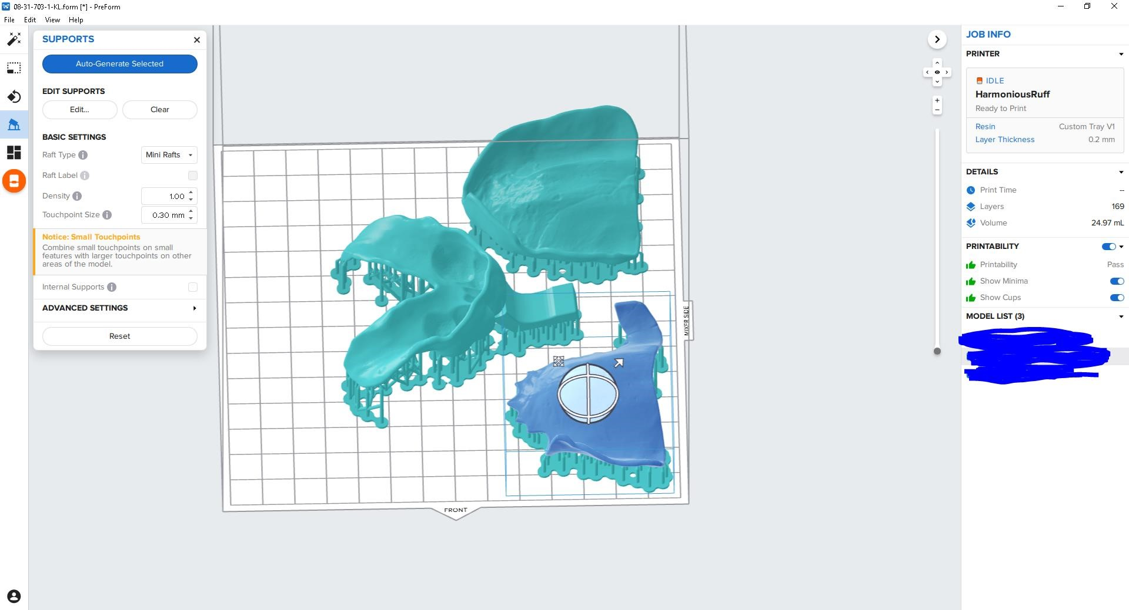Nesting: software is PreForm (blue butterfly)

|  |  |
| --- | --- |
| − | when the dialog box opens pick the printer of choice  − resin is Custom Tray  − layer thickness set to fastest print 200 microns − apply |
| − | drag and drop files from the windows directory \dima Print Cast |
| − | Orient print with the intaglio surface away from the plate (so that minimal supports get on it.) |

− lay the prints flat to the plate as above

|  |  |
| --- | --- |
|  |  |
| − | Supports:  − raft type = Mini rafts  − no raft labels  − density = 1.00  − touchpoint size = 0.30mm  − internal supports off  − Auto-Generate All |
| − | Check for and supports on the intaglio surfaces. Remove if necessary.  − For easier visibility select the model. It will turn blue and the supports will be green. |
| − | Layout All |
| − | Check the slices. |
| − | Save file as month-day-70(3/4/5)-#-initials |
| − | Check printability |
| −    Printing: | use the Orange Printer button to send to the printer. |
| − | Remove the resin tank and while holding upside down give it a good left right shake. Put it back. |
| − | Open the vent on resin tank |
| − | check the plate (clean and proper position) |
| − | verify that you have the correct file and hit print on the printer. Follow prompts. |

Removal and Curing:

− remove plate

− at the processing station use the super bendy black handle scraper to remove the prints

− place them in the dirty (previously used) IPA for 280 seconds or 5 minutes in the ultrasonic

− blow out between supports and print

− place in clean IPA for 280 seconds in the ultrasonic

− give a light blow off and air dry for 30 minutes (if time sensitive you can blow off at 10 minutes and then cure for 30 minutes)

− 30 minutes in the Accu-Cure

− remove supports and clean up with clippers

formlabs reference https://dental.formlabs.com/indications/custom-trays-guide/

|  |  |
| --- | --- |
| − | Upon completion of wax rims, if the pallet does not sit tight to the model, stand them nearly vertical or at about 45degs to the plate, distal side to plate (with a slight tilt with the intaglio side away from the plate) as below |

